**Resume**

**Email: bawaskarajay98@gmail.com**

**Name: Ajay Bawaskar Mobile: +91-9552493684**

**Professional Summary:**

# Having overall 2.8 years of experience in Application Development and Enhancement and implementation of web-based application.

* **Good experience in developing applications using JAVA/J2EE technologies like Java, JDBC, Servlets, JSP, Spring, Spring Boot, Restful Services, Design Patterns, and Micro Services.**
* **Having Good Work Experience in Developing both Monolithic and Micro Services Based Applications.**
* **Having good experience in Apache Kafka for processing stream of data.**
* **Experience with Software Development Processes & Models: Agile, Waterfall Models.**
* **Extensive experience in working with MySQL and H2 databases.**
* **Excellent analytical and programming abilities in using technology to create flexible and maintainable solutions for complex development problems.**
* **Having Good Work Experience in using JIRA tool for Project Management.**
* **Having Good experience in code review using SONAR QUBE.**
* **Excellent team player and ability to adapt to changes quickly and efficiently.**
* **Experience in dealing with on-shore and offshore teams.**

**Experience Summary:**

# Working as Software Engineer with Binary Books Technology Pvt. Ltd. from March-2022 to till date

# Worked as Java Developer with Stance Code Technology Pvt. Ltd. from December-2020 to February-2022

**Technical Skills:**

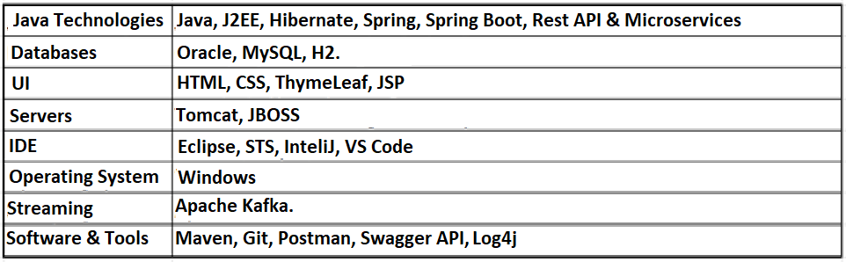

**Educational Qualification:**

## Bachelor of Computer Application (BCA) form SGBAU.

**Project Details:**

## Project # 1: Billing Market System

**Environment: Java, Spring, Hibernate, MySQL**

**Role: Team Member.**

**Description**

Billing market Simplify the store management and provides solution to create invoice of product which is sell. Invoice is made by including different discount applied to product such percentages and many other.

Allow Inventory management by providing number of items remaining of product and it also notify Retailer or Restaurant about warning if number of items are below certain level Billing market.

It also helps to create purchase Invoice to purchase products form different supplier.

**Responsibilities**

* Responsible for coding and developing application using Java.
* Discuss implementation approach with functional manager.
* Writing Hibernate, mapping files and maintain Database
* Involved in the Unit test and Integration testing

## Project # 2: Health Insurance System

**Environment: Java, JSP, Spring, Spring Boot, Hibernate, Web Services, Restful Services, MySQL.**

**Industry: Health and Human Services Service Area**

**Role: Team Member**

**Description**

The objective of the project is to implement a fully integrated Health Insurance Exchange and Integrated Eligibility System for Kentucky state citizens. As part of this application, we are providing below health and insurance plans for citizens.

1. SNAP
2. CCAP
3. Medicaid

**Responsibilities**

* Developed Component classes using MVC patterns
* Developed Persistence layer using Hibernate framework
* Created server controls using Spring Controller classes
* Involved in code review using Sonar Qube
* Involved in the Unit test and Integration testing

I hereby declare that all of the details furnished above are true on the best of my knowledge and belief.

**PLACE**: **Pune** **Ajay Bawaskar**

**DATE**: